Experiment 20
Implement Future Sales Prediction using a suitable machine learning algorithm
Aim
To implement Future Sales Prediction using a suitable Machine Learning algorithm (Linear Regression) in Python.
Program
# Future Sales Prediction using Linear Regression

import pandas as pd
from sklearn.linear_model import LinearRegression
from sklearn.metrics import mean_squared_error

# Dataset (Month vs Sales)
data = {
'Month': [1, 2, 3, 4, 5],
'Sales': [200, 250, 300, 350, 400]
}

df = pd.DataFrame(data)

# Features and target
X = df[['Month']]
y = df['Sales']

# Model
model = LinearRegression()
model.fit(X, y)

# Predict future sales (next months)
future_months = [[6], [7]]
predictions = model.predict(future_months)

print("Future Sales Predictions:")
for i, val in enumerate(predictions, start=6):
print("Month", i, ":", val)

# Training prediction error
y_pred = model.predict(X)
mse = mean_squared_error(y, y_pred)
print("Mean Squared Error:", mse)
Output
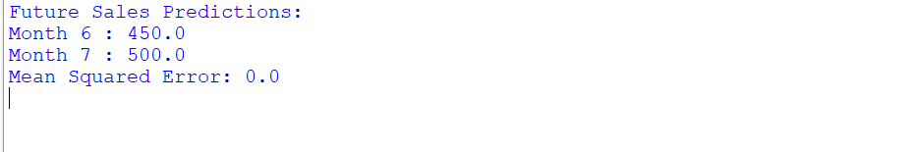

Result
The Future Sales Prediction model was successfully implemented in Python using Linear Regression, and future sales values were predicted based on past data.

